UNITED STATES OF AMERICA
FEDERAL ENERGY REGULATORY COMMISSION
Mountain Valley Pipeline, LLC Docket No. CP25-60-000
NOTICE OF SCOPING PERIOD REQUESTING COMMENTS ON ENVIRONMENTAL ISSUES
FOR THE PROPOSED MOUNTAIN VALLEY PIPELINE SOUTHGATE AMENDMENT PROJECT,
AND NOTICE OF PUBLIC SCOPING SESSION

(May 22, 2025)

The staff of the Federal Energy Regulatory Commission (FERC or Commission) will prepare an environmental document that will discuss the environmental impacts of the Mountain Valley Pipeline (MVP) Southgate Amendment Project (Amendment Project) involving construction and operation of facilities by Mountain Valley Pipeline, LLC (MVP) in Pittsylvania County, Virginia and Rockingham County, North Carolina. The Commission will use this environmental document in its decision-making process to determine whether the Amendment Project is in the public convenience and necessity.

This notice announces the opening of the scoping process the Commission will use to gather input from the public and interested agencies regarding the Amendment Project. As part of the National Environmental Policy Act (NEPA) review process, the Commission takes into account concerns the public may have about proposals and the environmental impacts that could result from its action whenever it considers the issuance of Certificate of Public Convenience and Necessity. This gathering of public input is referred to as “scoping.” The main goal of the scoping process is to focus the analysis in the environmental document on the important environmental issues. Additional information about the Commission’s NEPA process is described below in the NEPA Process and Environmental Document section of this notice.

By this notice, the Commission requests public comments on the scope of issues to address in the environmental document. To ensure that your comments are timely and properly recorded, please submit your comments so that the Commission receives them in Washington, DC on or before 5:00 pm Eastern Time on June 21, 2025. Comments may be submitted in written or oral form. Further details on how to submit comments are provided in the Public Participation section of this notice.

Your comments should focus on the potential environmental effects, reasonable alternatives, and measures to avoid or lessen environmental impacts. Your input will help the Commission staff determine what issues they need to evaluate in the environmental document. Commission staff will consider all written or oral comments during the preparation of the environmental document.

If you submitted comments on this Amendment Project to the Commission before the opening of this docket on February 3, 2025, you will need to file those comments in Docket No. CP25-60-000 to ensure they are considered as part of this proceeding.

This notice is being sent to the Commission’s current environmental mailing list for this Amendment Project. State and local government representatives should notify their constituents of this proposed Amendment Project and encourage them to comment on their areas of concern.

If you are a landowner receiving this notice, a pipeline company representative may contact you about the acquisition of an easement to construct, operate, and maintain the proposed facilities. The company would seek to negotiate a mutually acceptable easement agreement. You are not required to enter into an agreement. However, if the Commission approves the Amendment Project, the Natural Gas Act conveys the right of eminent domain to the company. Therefore, if you and the company do not reach an easement agreement, the pipeline company could initiate condemnation proceedings in court. In such instances, compensation would be determined by a judge in accordance with state law. The Commission does not subsequently grant, exercise, or oversee the exercise of that eminent domain authority. The courts have exclusive authority to handle eminent domain cases; the Commission has no jurisdiction over these matters.

MVP provided landowners with a fact sheet prepared by the FERC entitled “An Interstate Natural Gas Facility On My Land? What Do I Need To Know?” which addresses typically asked questions, including the use of eminent domain and how to participate in the Commission’s proceedings. This fact sheet along with other landowner topics of interest are available for viewing on the FERC website (www.ferc.gov) under the Natural Gas, Landowner Topics link.

Public Participation

There are four methods you can use to submit your comments to the Commission. Please carefully follow these instructions so that your comments are properly recorded. The Commission encourages electronic filing of comments and has staff available to assist you at (866) 208-3676 or FercOnlineSupport@ferc.gov.

- You can file your comments electronically using the eComment feature, which is located on the Commission’s website (www.ferc.gov) under the link to FERC Online. Using eComment is an easy method for submitting brief, text-only comments on a project;

- You can file your comments electronically by using the eFiling feature, which is located on the Commission’s website (www.ferc.gov) under the link to FERC Online. With eFiling, you can provide comments in a variety of formats by attaching them as a file with your submission. New eFiling users must first create an account by clicking on “eRegister.” You will be asked to select the type of filing you are making; a comment on a particular project is considered a “Comment on a Filing”;

- You can file a paper copy of your comments by mailing them to the Commission. Be sure to reference the Amendment Project docket number (CP25-60-000) on your letter. Submissions sent via the U.S. Postal Service must be addressed to: Debbie-Anne A. Reese, Secretary, Federal Energy Regulatory Commission, 888 First Street NE, Room 1A, Washington, DC 20426. Submissions sent via any other carrier must be addressed to: Debbie-Anne A. Reese, Secretary, Federal Energy Regulatory Commission, 12225 Wilkins Avenue, Rockville, Maryland 20852; or

4) In lieu of sending written comments, the Commission invites you to attend one of the public scoping sessions its staff will conduct in the Amendment Project area, scheduled as follows:

Date and Time | Location
Monday, June 16, 2025  5:00 to 8:00 pm | Olde Dominion Agricultural Complex  19783 U.S. Highway 29  Chatham, VA 24531  434-432-8026
Tuesday, June 17, 2025  5:00 to 8:00 pm | Rockingham County Community College  ADT Auditorium  560 County Home Road  Wentworth, NC 27375  336-342-4261

The primary goal of these scoping sessions is to have you identify the specific environmental issues and concerns that should be considered in the environmental document. Individual oral comments will be taken on a one-on-one basis with a court reporter. This format is designed to receive the maximum amount of oral comments in a convenient way during the timeframe allotted.

Each scoping session is scheduled from 5:00 pm to 8:00 pm Eastern Time. There will not be a formal presentation by Commission staff when the session opens. If you wish to speak, the Commission staff will hand out numbers in the order of your arrival, starting at 5:00 pm. Comments will be taken until 8:00 pm. However, if no additional numbers have been handed out and all individuals who wish to provide comments have had an opportunity to do so, staff may conclude the session at 7:30 pm. Please see Appendix 1 for additional information on the session format and conduct.

Your oral comments will be recorded by a court reporter (with FERC staff or FERC representative present) and become part of the public record for this proceeding. Transcripts will be publicly available on FERC’s eLibrary system (see the last page of this notice for instructions on using eLibrary). If a significant number of people are interested in providing oral comments in the one-on-one settings, a time limit of 5 minutes may be implemented for each commentor. Although there will not be a formal presentation, Commission staff will be available throughout the scoping session to answer your questions about the environmental review process. Representatives from MVP will also be present to answer project-specific questions.

It is important to note that the Commission provides equal consideration to all comments received, whether filed in written form or provided orally at a scoping session.

Additionally, the Commission offers a free service called eSubscription, which makes it easy to stay informed of all issuances and submittals regarding the dockets/projects to which you subscribe. These instant email notifications are the fastest way to receive notification and provide a link to the document files which can reduce the amount of time you spend researching proceedings. Go to https://www.ferc.gov/ferc-online/overview to register for eSubscription.

The Commission’s Office of Public Participation (OPP) supports meaningful public engagement and participation in Commission proceedings. OPP can help members of the public, including landowners, community organizations, Tribal members and others, access publicly available information and navigate Commission processes. For public inquiries and assistance with making filings such as interventions, comments, or requests for rehearing, the public is encouraged to contact OPP at (202) 502-6595 or OPP@ferc.gov.

Summary of the Proposed Amendment Project

In February 2020, FERC issued a final Environmental Impact Statement (EIS) that analyzed the Southgate Project. On June 18, 2020, the Commission authorized the Southgate Project. MVP further evaluated the Southgate Project and proposes modifications as part of the Amendment Project. On February 3, 2025, MVP filed an application with FERC for the Amendment Project in Docket No. CP25-60-000.

The Amendment Project includes the following modifications to the previously authorized Southgate Project.

- The Lambert Compressor Station has been removed and is no longer proposed;
- The length of the pipeline has decreased from 75.1 miles to 31.3 miles;
- The pipeline diameter would increase from 16- and 24-inch diameters to 30-inch diameter;
- The pipeline’s operating capacity would increase from 375,000 dekatherms per day (Dth/d) to 550,000 Dth/d;
- The Southgate Project included four meter (interconnect) stations. The Amendment Project would also include four meter (interconnect) stations, one of which would include a pig launcher and one which would include a pig receiver. Two of the four meter stations are new facilities identified for the Amendment Project, but are entirely located within Southgate Project certificated workspace;
- Six route deviations from the Southgate Project (totaling 3.1 miles) have been incorporated into the Amendment Project. Centerline shifts for the route deviations generally range from 25 feet to about 1,410 feet, for engineering and environmental reasons;
- Eight mainline valves were in the Southgate Project; four have been removed and are no longer proposed;
- Four cathodic protection groundbeds were in the Southgate Project; two have been removed and are no longer proposed;
- 13.5 acres of additional temporary workspaces were added;
- Two new contractor yards were added; and
- 3.8 acres of temporary access roads were added.

The general location of the Amendment Project facilities is shown in Appendix 2.

Land Requirements for Construction

The modifications associated with the Amendment Project would result in a total impact footprint of approximately 51.0 acres of land outside of the workspace that was previously certificated for the Southgate Project. This includes the pipeline; additional temporary workspaces; contractor yards; and new or improved access roads. The modifications associated with the Amendment Project would result in 11.3 acres of permanent impact for operation of the Amendment Project. The Southgate Project, as approved by the Commission in 2020, would have affected 1,465.9 acres for construction and 450.0 acres for operation.

NEPA Process and the Environmental Document

Any environmental document issued by the Commission will discuss impacts that could occur as a result of the construction and operation of the proposed Amendment Project under the relevant general resource areas:

- geology and soils;
- water resources and wetlands;
- vegetation and wildlife;
- threatened and endangered species;
- cultural resources;
- land use;
- air quality and noise; and
- reliability and safety.

Commission staff have already identified several issues that deserve attention based on a preliminary review of the proposed facilities and the environmental information provided by MVP. This preliminary list of issues may change based on your comments and our analysis:

- waterbodies and wetlands;
- forested areas;
- cumulative impacts;
- pipeline safety associated with the increased diameter and capacity.

Commission staff will also evaluate reasonable alternatives to the proposed Amendment Project or portions of the Amendment Project and make recommendations on how to lessen or avoid impacts on the various resource areas. Your comments will help Commission staff identify and focus on the issues that might have an effect on the human environment and potentially eliminate others from further study and discussion in the environmental document.

Following this scoping period, Commission staff will determine whether to prepare an Environmental Assessment (EA) or an Environmental Impact Statement (EIS). The EA or the EIS will present Commission staff’s independent analysis of the issues. If Commission staff prepares an EA, a Notice of Schedule for the Preparation of an Environmental Assessment will be issued. The EA may be issued for an allotted public comment period. The Commission would consider timely comments on the EA before making its decision regarding the proposed Amendment Project. If Commission staff prepares an EIS, a Notice of Intent to Prepare an EIS/Notice of Schedule will be issued, which will open up an additional comment period. Staff will then prepare a draft EIS which will be issued for public comment. Commission staff will consider all timely comments received during the comment period on the draft EIS and revise the document, as necessary, before issuing a final EIS. Any EA or draft and final EIS will be available in electronic format in the public record through eLibrary and the Commission’s natural gas environmental documents webpage (https://www.ferc.gov/industries-data/natural-gas/environment/environmental-documents). If eSubscribed, you will receive instant email notification when the environmental document is issued.

With this notice, the Commission is asking agencies with jurisdiction by law and/or special expertise with respect to the environmental issues of this Amendment Project to formally cooperate in the preparation of the environmental document. Agencies that would like to request cooperating agency status should follow the instructions for filing comments provided under the Public Participation section of this notice. Currently, the U.S. Fish and Wildlife Service’s Virginia and North Carolina Ecological Services Field Offices have expressed their intention to participate as a cooperating agency in the preparation of the environmental document.

Consultation Under Section 106 of the National Historic Preservation Act

In accordance with the Advisory Council on Historic Preservation’s implementing regulations for section 106 of the National Historic Preservation Act, the Commission is using this notice to initiate consultation with the applicable State Historic Preservation Office(s), and to solicit their views and those of other government agencies, interested Indian tribes, and the public on the Amendment Project’s potential effects on historic properties. The environmental document for this Amendment Project will document findings on the impacts on historic properties and summarize the status of consultations under section 106.

Environmental Mailing List

The environmental mailing list includes federal, state, and local government representatives and agencies; elected officials; environmental and public interest groups; Native American Tribes; newspapers; libraries; and other interested parties. This list also includes all affected landowners (as defined in the Commission’s regulations) who are potential right-of-way grantors, whose property may be used temporarily for Amendment Project purposes, or who own homes within certain distances of aboveground facilities, and anyone who submits comments on the Amendment Project and includes a mailing address with their comments. Commission staff will update the environmental mailing list as the analysis proceeds to ensure that Commission notices related to this environmental review are sent to all individuals, organizations, and government entities interested in and/or potentially affected by the proposed Amendment Project.

If you need to make changes to your name/address, or if you would like to remove your name from the mailing list, please complete one of the following steps:

- Send an email to GasProjectAddressChange@ferc.gov stating your request. You must include the docket number CP25-60-000 in your request. If you are requesting a change to your address, please be sure to include your name and the correct address. If you are requesting to delete your address from the mailing list, please include your name and address as it appeared on this notice. This e-mail address is unable to accept comments.

OR

- Return the attached “Mailing List Update Form” (Appendix 3).

Additional Information

Additional information about the Amendment Project is available from the Commission’s Office of External Affairs, at (866) 208-FERC, or on the FERC website at www.ferc.gov using the eLibrary link. Click on the eLibrary link, click on “General Search” and enter the docket number in the “Docket Number” field. Be sure you have selected an appropriate date range. For assistance, please contact FERC Online Support at FercOnlineSupport@ferc.gov or (866) 208-3676, or for TTY, contact (202) 502-8659. The eLibrary link also provides access to the texts of all formal documents issued by the Commission, such as orders, notices, and rulemakings.

Public sessions or site visits will be posted on the Commission’s calendar located at https://www.ferc.gov/news-events/events along with other related information.

Debbie-Anne A. Reese,
Secretary.

Appendix 1

Session Format
FERC is conducting the session to solicit your scoping comments. There will not be a formal presentation by Commission staff; however, FERC staff is available to answer questions about the environmental review process. The session format is as follows:
- Tickets are handed out on a “first come, first serve” basis starting at the time listed in the Notice.
- Individuals are called in ticket number order to provide oral comments to be transcribed by a court reporter for the public record.
- Time limits on oral comments may be enforced to ensure that all those wishing to comment have the opportunity to do so within the designated session time.
- Written comments may be submitted in addition to, or in lieu of, oral comments.
- Additional materials about FERC and the environmental review process are available at information stations at the session.
Session Conduct
Proper conduct will help the sessions maintain a respectful atmosphere for attendees to learn about the FERC Environmental Review Process and to be able to provide comments effectively.

- Loudspeakers, lighting, oversized visual aids, or other visual or audible disturbances are not permitted.
- Disruptive video and photographic equipment may not be used.
- Conversations should be kept to a reasonable volume. Attendees should be respectful of those providing oral comments to the court reporters.
- Recorded interviews are not permitted within the session space.
- FERC reserves the right to end the session if disruptions interfere with the opportunity for individuals to provide oral comments or if there is a safety or security risk.

Appendix 2

Mountain Valley Pipeline Southgate Amendment Project Overview Map

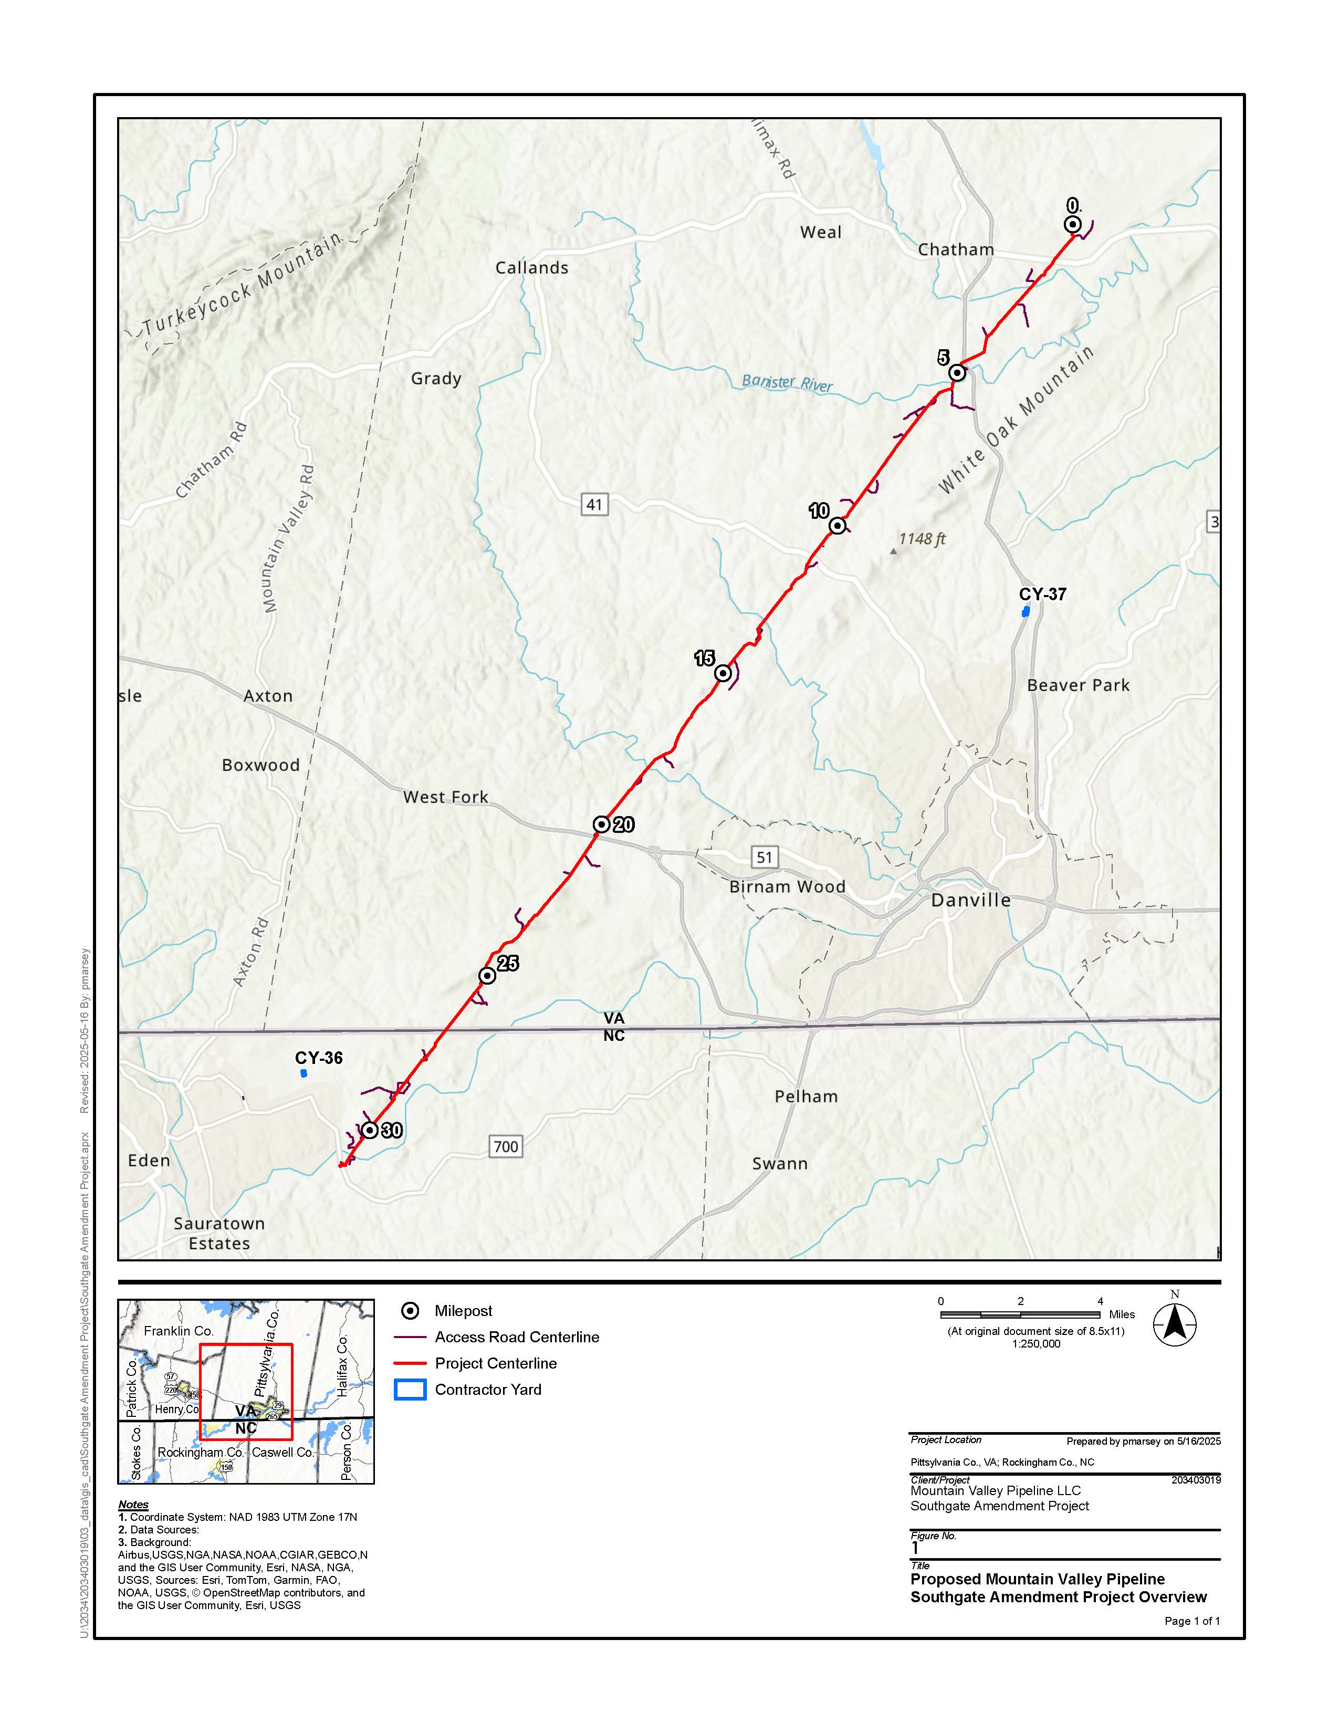

Mountain Valley Pipeline Southgate Amendment Project Route Deviations from the Southgate Project

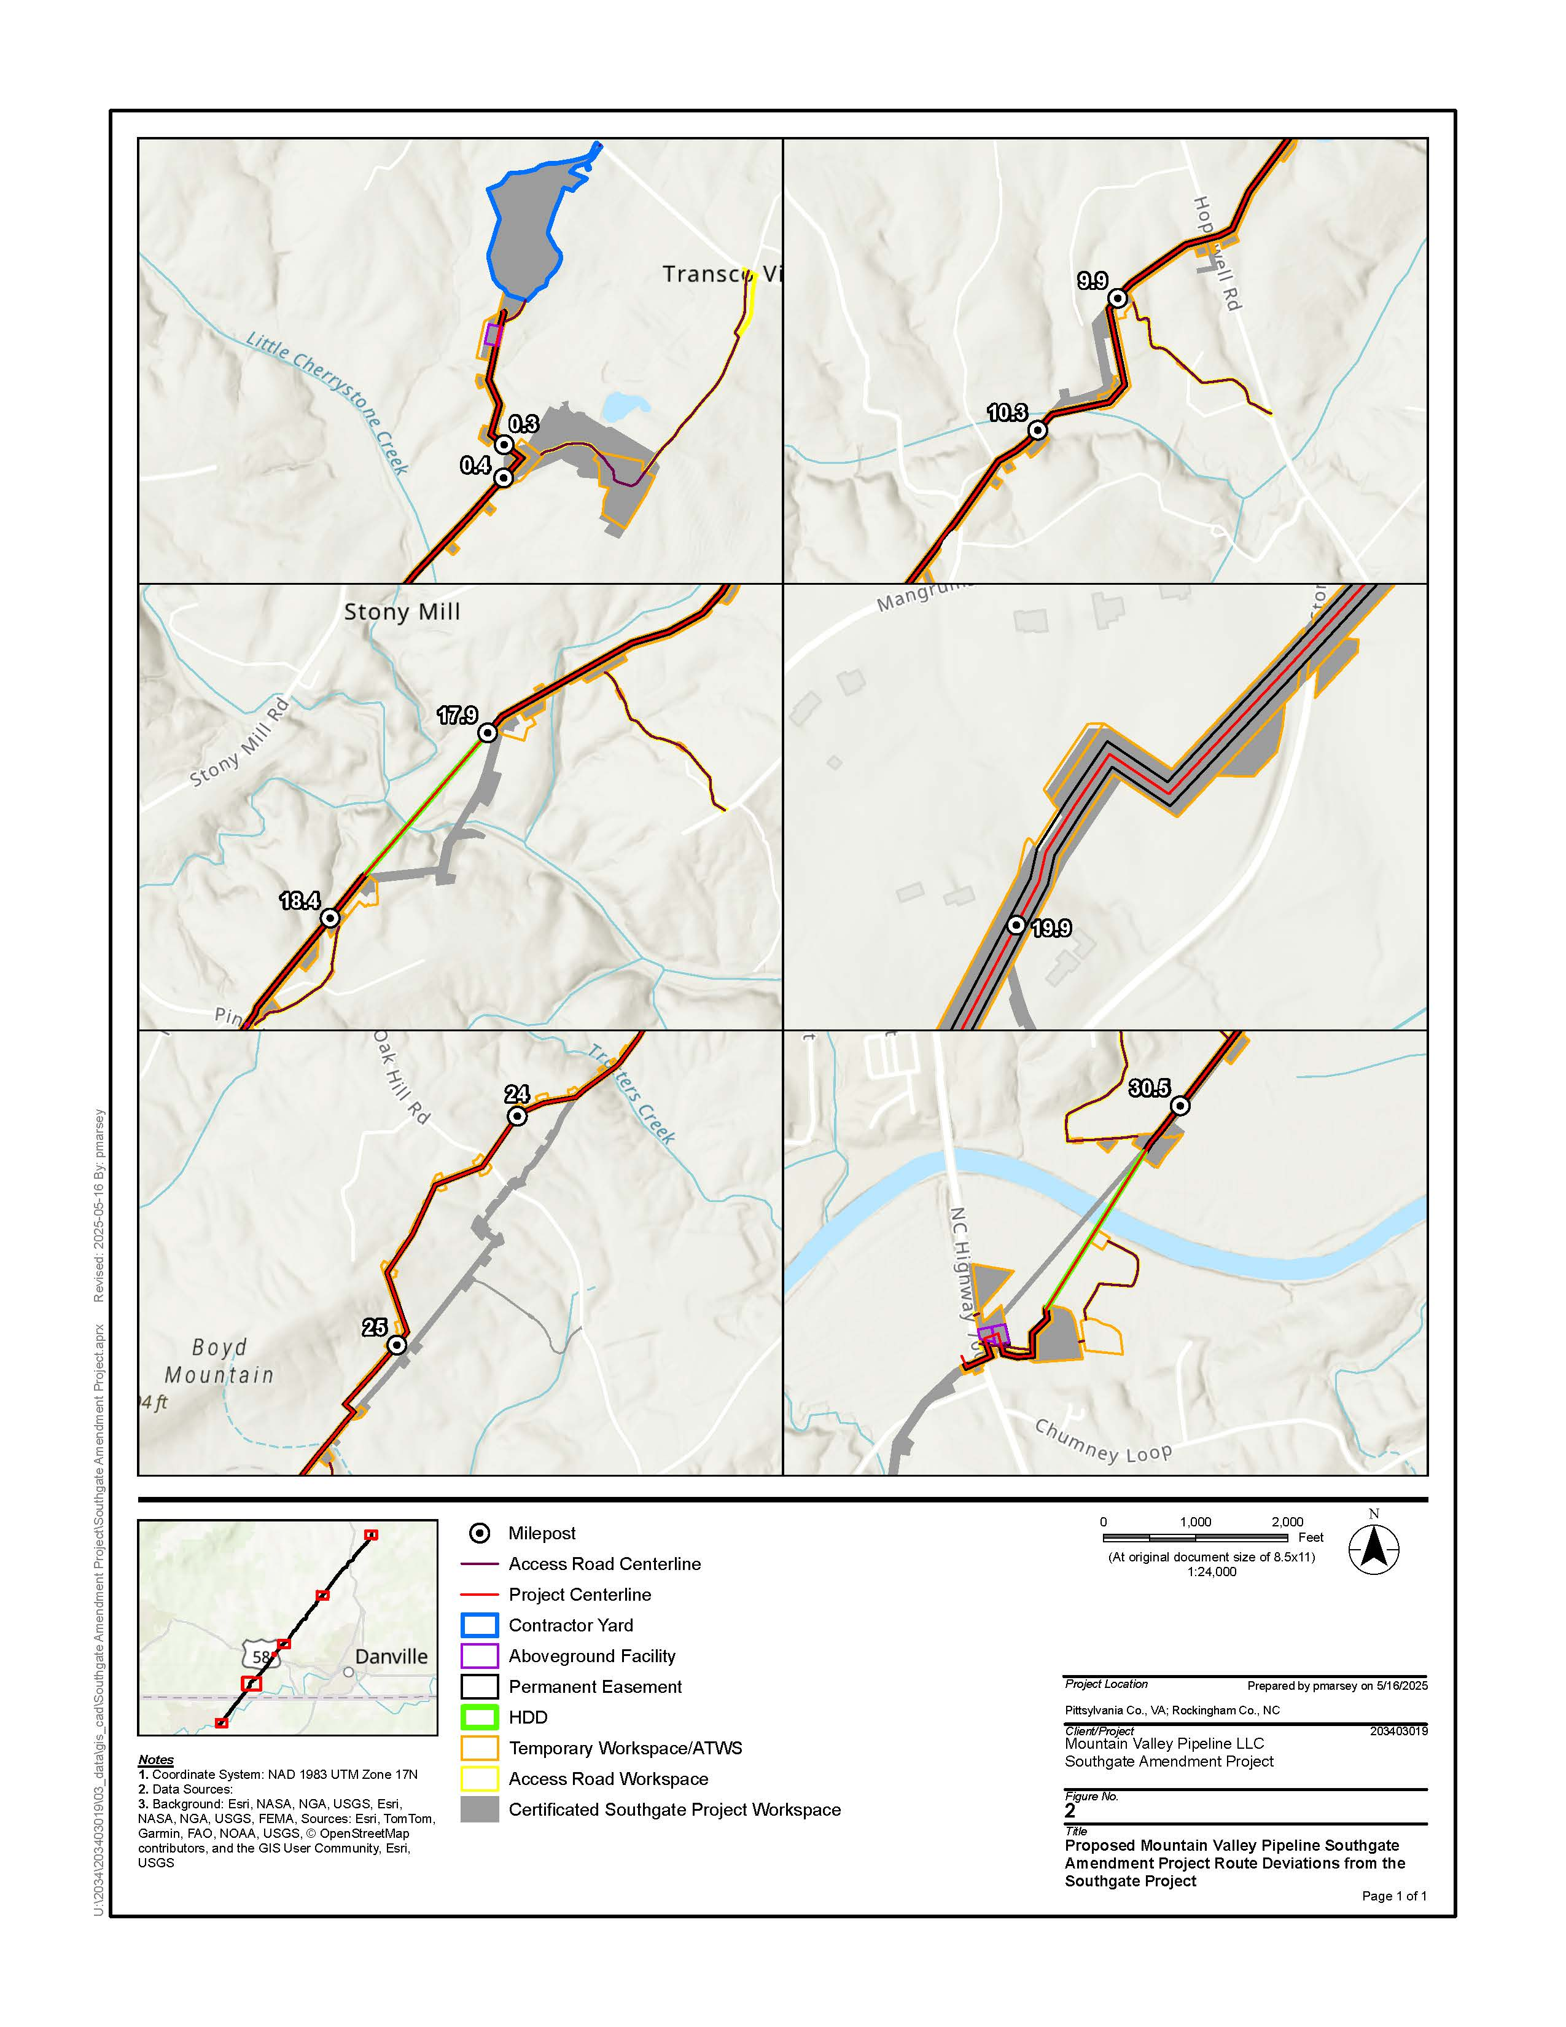

Appendix 3

MAILING LIST UPDATE FORM
Mountain Valley Pipeline Southgate Amendment Project

Name
Agency
Address
City State Zip Code
□ Please update the mailing list
□ Please remove my name from the mailing list

FROM

ATTN: OEP - Gas 3, PJ - 11.3
Federal Energy Regulatory Commission
888 First Street NE
Washington, DC 20426

CP25-60-000 - Mountain Valley Pipeline Southgate Amendment Project

Staple or Tape Here

The appendices referenced in this notice will not appear in the Federal Register. Copies of the appendices were sent to all those receiving this notice in the mail and are available at www.ferc.gov using the link called “eLibrary”. For instructions on connecting to eLibrary, refer to the last page of this notice. For assistance, contact FERC at FERCOnlineSupport@ferc.gov or call toll free, (886) 208-3676 or TTY (202) 502-8659.
Construction of the Southgate Project has not yet started.
A “pig” is a tool that the pipeline company inserts into and pushes through the pipeline for cleaning the pipeline, conducting internal inspections, or other purposes.
For instructions on connecting to eLibrary, refer to the last page of this notice.
Cooperating agency responsibilities are addressed in section 107(a)(3) of NEPA (42 U.S.C. § 4336(a)(3)).
The Advisory Council on Historic Preservation’s regulations are at Title 36, Code of Federal Regulations, Part 800. Those regulations define historic properties as any prehistoric or historic district, site, building, structure, or object included in or eligible for inclusion in the National Register of Historic Places.

